**Homework 10**

**Fall 2010 HW 10**

1. The US domestic supply of cotton and domestic demand for cotton are given by: QUSS = .03P and QUSD = 5.5 -.025P. Price is measured in cents per pound and quantity is measured in millions of tons per year. The world price of cotton is 60 cents per pound and the US is a price taker on the world cotton market.

1. Given the domestic supply and demand curves for cotton what is the US demand curve for cotton imports?



1. Given the world price of cotton how many pounds of cotton will the US choose to import in the absence of trade restrictions? How many pounds of cotton would US consumers purchase? How many pounds of cotton will US producers supply? Illustrate your answer.

U.S. consumers purchase 5.5-0.025*60 =4

U.S. producers supply 0.03*60 = 1.8

The quantity imported = 2.2

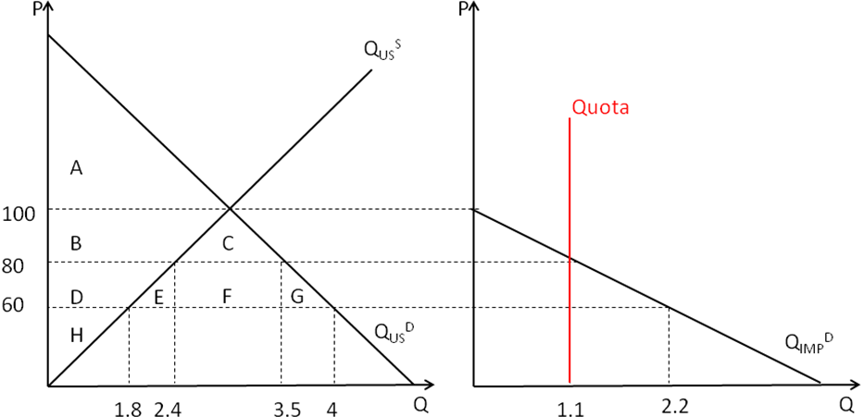

Suppose that US cotton producers successfully lobby congress to place a quota on the importation of cotton of 1.1 million tons per year (so a maximum of 1.1 million tons may be imported).

1. Illustrate the effect of the quota on the import market in your diagram for part (b).
2. What will be the effect of the import quota on the domestic price and consumption of cotton in the US? How many pounds of cotton will domestic producers supply at this price?

Under the quota of 1.1, the demand for imports will pin down the price :

QIMPD=5.5-0.055P ; 1.1 = 5.5- 0.055P ; P = 80

U.S. consumers purchase 5.5-0.025*80 =3.5

U.S. producers supply 0.03*80 = 2.4

1. In your diagram for part (b) illustrate the effect of the import quota on market for cotton in the US. In your diagram you must indicate the following areas:
2. change in consumer surplus;
3. change in producer surplus

|  |  |  |  |
| --- | --- | --- | --- |
|  | Without Quota | With Quota | Change |
| CS | A+B+C+D+E+F+G | A+B+C | -( D+E+F+G) |
| PS | H | D+H | +D |

DWL = E+G

1. If the quota rights are given (for free) to foreign cotton producers then what is the dollar value of the *rents* (profits) earned by these foreign producers? Illustrate these rents in your diagram for part (b).

Rents = F=(80-60)*1.1

1. If the US government chose to sell quota rights what do you predict would be the free- market price for the right to sell one ton of cotton?

Should be 80-60 =20

2. The US domestic supply of soybean oil and domestic demand for soybean oil are given by: **QUSS = 2P** and **QUSD = 720 - 10P.** Price is measured in dollars per pound and quantity is measured in millions of pounds per year.

1. Given the domestic supply and demand curves for soybean oil what is the US demand curve for soybean oil imports?

**QIMPD = QUSD-QUSS=720-10P – 2P =720-12P**

Suppose that the US faces an upward sloping world supply **QSworld= 12P**.

1. Given the world supply curve of soybean oil how many pounds of soybean oil will the US choose to import? What would be the domestic price of soybean oil in the US? How many pounds of soybean oil would US consumers purchase? Illustrate your answer on the next page.

**QIMP= 360 ; P =30 ;**

**U.S. consumers purchase 420 pounds**

**U.S. producers supply 60 pounds**

**Price Floor**

US soybean oil producers successfully lobby congress to place price floor on the soybean oil market of $35 per pound.

1. Illustrate the effect of the price floor on the import and domestic markets in your diagram for part (b).

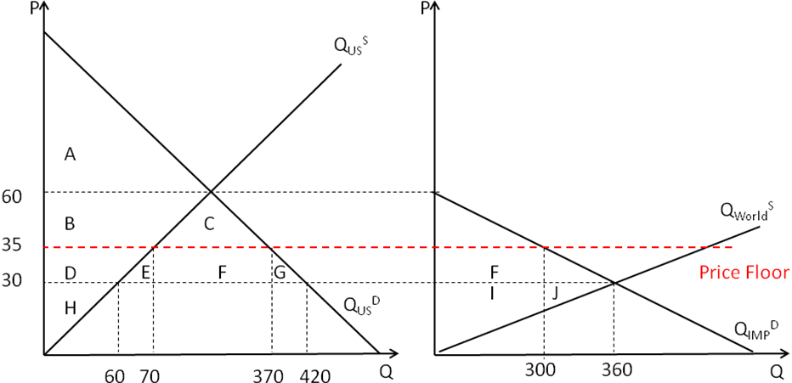

1. What will be the effect of the price floor on the domestic production and consumption of soybean oil in the US?

**P =35 ; QIMP= 300 ;**

**U.S. consumers purchase 370 pounds**

**U.S. producers supply 70 pounds**

1. In your diagram for part (b) illustrate the following impacts on US total surplus of the price floor :
2. change in consumer surplus
3. change in the surplus of the foreign suppliers
4. dead-weight loss.

|  |  |  |  |
| --- | --- | --- | --- |
|  | Before | After | Change |
| CS | **A+B+C+D+E+F+G** | **A+B+C** | **-(D+E+F+G)** |
| PS | **H** | **D+H** | **+D** |

**F becomes Foreign Suppliers’ surplus**

**E+G : DWL**

1. Calculate the value of the change in foreign supplier surplus. What was the source of their additional surplus?

**Foreign Supplier’s Surplus : I+J => I+F :**

**Change = = -J+F=-(1/2)*60*5 + 300*5 = 1350**

**Per Unit Tariff**

Suppose that the government chose to impose a per unit import tariff instead of the price floor.

1. Given the demand for imports and the world supply, what is the incidence of a per unit tariff on foreign suppliers (I am looking for the numerical answer)?



1. Given your answer to part (g), what tariff rate should the government set so that the domestic price rises to $35?

Tariff rate t = 10

1. Illustrate the effect of the tariff on the domestic price and consumption of soybean oil in the US.

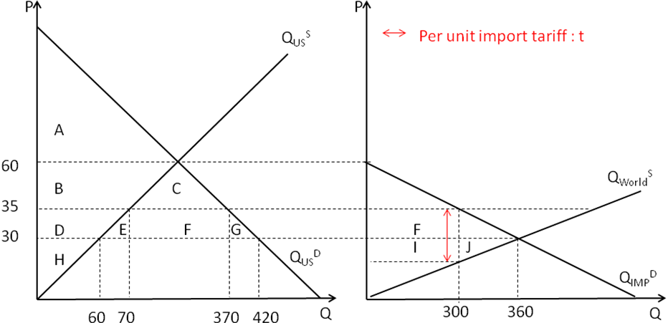

$10 per unit tariff ; Domestic price = 35

Consumption = 370 ; Domestic supplies = 70 ; Import = 300

1. Use your diagram to show that only a fraction of the tariff revenues are raised from US consumers. What is the source of the remaining tariff revenues?

|  |  |  |  |
| --- | --- | --- | --- |
|  | Before | After | Change |
| CS | A+B+C+D+E+F+G | A+B+C | -(D+E+F+G) |
| PS | H | D+H | +D |
| Tariff Rev | 0 | F+I | +(F+I) |

Total Government Revenue from Tariff = F+I

Government Revenue from domestic consumers = F

Government Revenue from foreign firms = I

1. Show algebraically that in this case US surplus is in fact higher after the tariff is imposed.

Changes in U.S. surplus = +I – (E+G)

= 300*5 –(10*5*0.5 + 50*5*0.5) = 1500 – (25 + 125)=1350

3. Suppose that the estimated supply and demand curves for oil are given by the following equations: QD = 8 - .3P + .002I and QS = 2 + .1Pwhere quantity is measured in millions of barrels per day, national income I is measured in billions of dollars and the price is dollars per barrel.

1. If national income is 1000 (1 trillion dollars) then given the supply and demand equations what is the market-clearing price for a barrel of oil? What is number of barrels of oil traded (per day)? Illustrate your answer.

P = 20 ; Q = 4

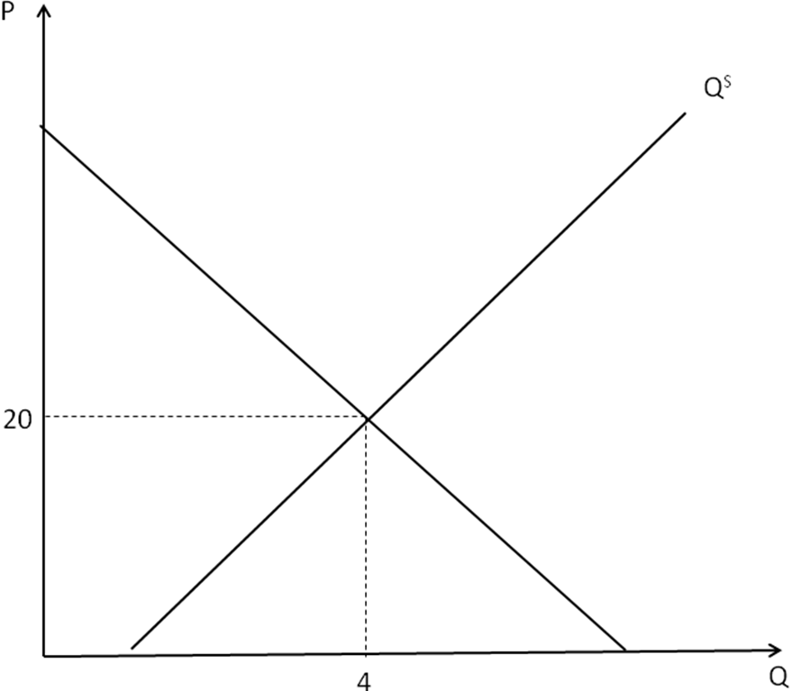

Suppose that national income rises.

1. In a new diagram illustrate the impact of the increase in national income on the supply and demand curves from (a) above. Be sure to indicate the new market clearing price and quantity in your diagram. Has the price risen or fallen in the market? Has the quantity traded risen or fallen?

New market clearing price = P’>20

New quantity traded = Q’ >4

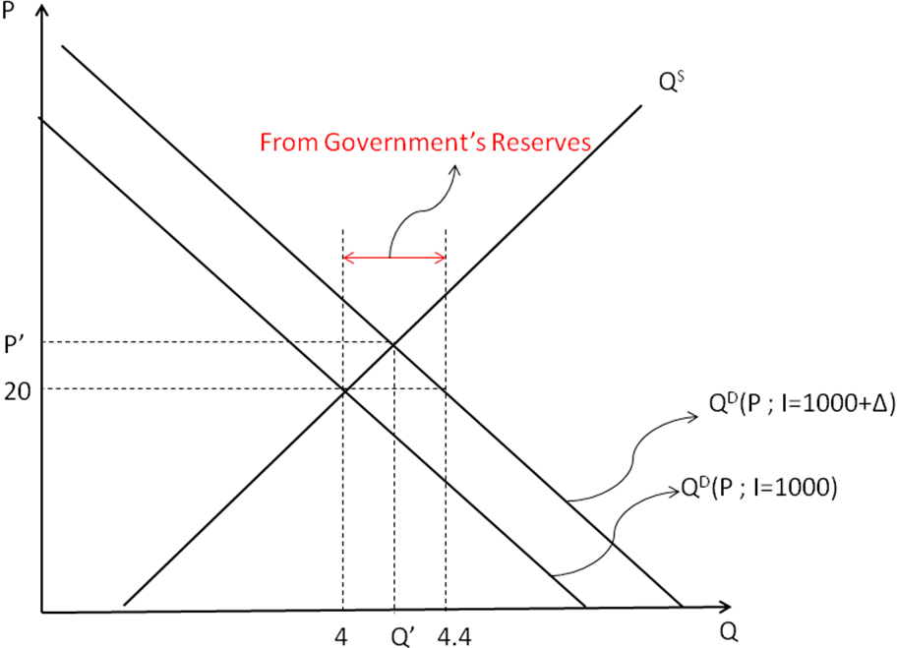

1. Use the technique from class to find an expression relating the change in the market clearing price of oil to the level of national income.

Market clearing price P will be a function of national income I ; P(I)

Therefore, in the equilibrium QD(P(I), I) = QS(P(I) )



Thus, 

1. Given the formula you found in (e), find the new market-clearing price for a barrel of oil after national income has risen by $200 billion. What is the new quantity traded?

P’ = P + 0.005*200 = 20+1 = 21

Q’ = 4.1

1. Suppose that the government wants to maintain price stability in the oil market. One way to keep the price from rising is to sell some of the governments own reserves of oil. How much oil would the government have to sell in order to keep the price at the original market clearing level (from (a) above)?

0.002*200 = 0.4

4. Sheila and Bruce are taking a long plane flight. Sheila brought 10 bags of peanuts (x) and 10 bags of chips (y). Sheila's utility function is US(x,y) = lnxS  + lnyS . Bruce brought 12 bags of peanuts and 8 bags of chips. Bruce's utility function is UB(x,y) = 3xB + yB

1. What are Bruce and Sheila’s marginal rates of substitution at the endowment point? In an Edgeworth box diagram illustrate the endowment point and draw a sample set of indifference curves through the endowment point.





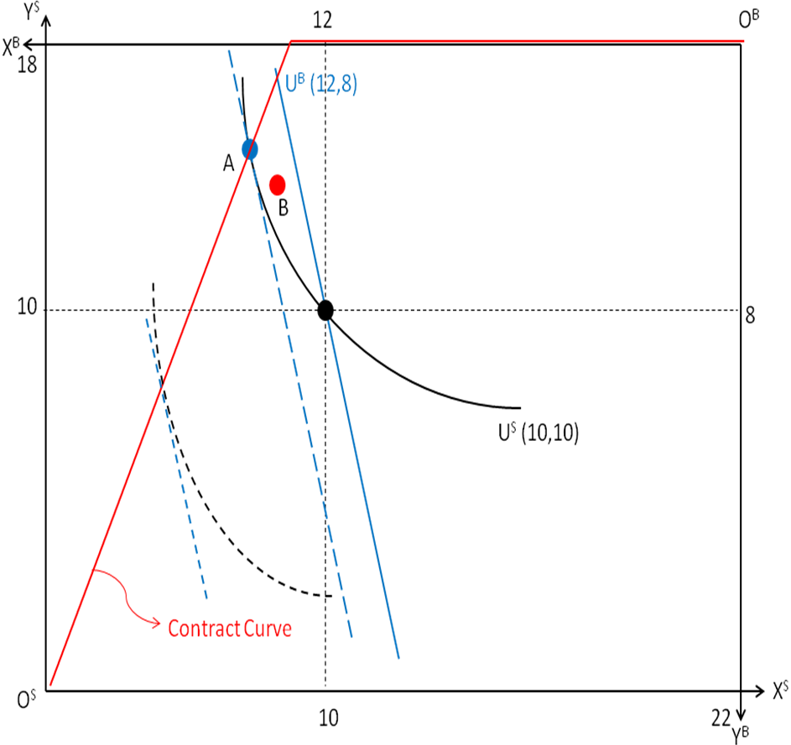

1. If Sheila and Bruce trade what will be the pattern of mutually beneficial trade? What will be the range of the terms of trade that are associated with mutually beneficial trade?

Sheila gives some of her x to Bruce and Bruce gives some of his y to Sheila.

The range of the terms of trade will be between their MRS. i.e. between 1 and 3

1. Provide an example of one trade that DOES NOT make both Sheila and Bruce strictly better off. Illustrate the allocation after the trade in your Edgeworth box.

Consider a bundle A. 

Since AS is on the same IC as (10,10), Sheila is not strictly better off but indifferent. However, Bruce is better off because 

1. Provide an example of one trade that DOES make both Sheila and Bruce strictly better off. Illustrate the allocation after the trade in your Edgeworth box diagram.

Consider a bundle B. 



1. Find the contract curve for this exchange economy and illustrate it in your diagram.

Solve MRSS = MRSB with xS+xB = 22, yS+yB = 18

i.e. (shown in red line)

5. Suppose that in the Bruce and Sheila exchange economy there are only 6 feasible allocations of the goods. The **utilities** of Bruce and Sheila for each of the 6 allocations is listed in the table below:

|  |  |  |  |  |  |  |
| --- | --- | --- | --- | --- | --- | --- |
| Allocation | 1 | 2 | 3 | 4 | 5 | 6 |
| Sheila’s utility | 20 | 25 | 30 | 18 | 35 | 22 |
| Bruce’s utility | 15 | 18 | 10 | 15 | 5 | 12 |

1. Which allocations are Pareto efficient?

Allocations 2, 3, and 5 are PE. The criterion for an allocation to be PE is that there’s no other allocation where one is better off without the other person being worse off.

The remaining questions discuss alternative criteria for selecting allocations (alternative to Pareto efficiency).

1. An alternative is the ***maxmin*** criteria whereby an allocation is selected if it gives the highest possible utility to the least well-off individual (for example in allocation 1 Bruce is the least well-off individual since 15 < 20). Which allocations are selected by the maxmin criteria? Are those allocations Pareto efficient in this example? Would those allocations be Pareto efficient in general? Does every Pareto efficient allocation satisfy the maxmin criteria?

Allocation 2 will be selected by the maxmin criterion. This is a PE allocation according to part a). In general these allocations will not be PE. Not every PE allocation satisfies the maxmin criteria, for example: allocation 5 is PE and is not selected by the maxmin criterion.

1. Another alternative is the ***utilitarian*** criteria whereby an allocation is selected if the sum of the utilities of the two individuals is the highest possible. Which allocations are selected by the utilitarian criteria? Are those allocations Pareto efficient in this example? Would those allocations be Pareto efficient in general? Does every Pareto efficient allocation satisfy the utilitarian criteria?

Allocation 2 will be selected by the utilitarian criterion; this is also a PE allocation. In general, such allocations will be PE, since otherwise we would be able to find another allocation where the sum of the utilities would be higher, and this would contradict the fact that the allocation chosen had the highest sum of utilities. The PE allocations need not satisfy the utilitarian criterion (like 3 and 5 for example).

1. Another is an ***equality*** criteria whereby an allocation is selected if the absolute value of the difference of the two utilities is as small as possible. Which allocations are selected by the equality criteria? Are those allocations Pareto efficient in this example? Would those allocations be Pareto efficient in general? Does every Pareto efficient allocation satisfy the equality criteria?

Allocation 4 will be selected by the equality criterion. It’s not a PE allocation, and in general allocations that satisfy equality criterion are not necessary to be a PE allocation. The PE allocations need not satisfy criterion either.

6. Sheila is endowed with 15 jars of peanut butter (x) and 8 jars of jelly (y) and Bruce is endowed with 9 jars of peanut butter and 10 jars of jelly. Sheila's utility function is

US(x,y) = xSyS and Bruce's is UB(x,y) = xB yB**.**

1. What are Bruce and Sheila’s marginal rates of substitution at the endowment point? In an Edgeworth box diagram illustrate the endowment point and draw a set of indifference curves through the endowment point. Is the endowment Pareto efficient? Why or why not?



Since the MRS of Sheila and Bruce are not equal at the endowment point and since the point is in the interior of the box, the allocation is not pareto efficient.

14.5

15

Bruce

Sheila

Total x = 24

Total y = 18

(15,8)

8

(9,10)

8.5

After Trade

1. If Sheila and Bruce trade what will be the pattern of mutually beneficial trade? What will be the range of the terms of trade that are associated with mutually beneficial trade?

If they trade Sheila will give up peanut butter and instead get more jelly. This can be seen by the geometry of the box (the Pareto Superior region is to the upper left of the endowment point) or by looking at the MRS of Sheila and Bruce. Sheilas MRS is smaller than Bruces, that is she prefers Peanut Butter relatively less than Bruce at the endowment point.

The terms of trade (the price ratio) will be between the two MRSs. Thus it will be between and .

1. Provide an example of one trade that would make both Sheila and Bruce strictly better off. Illustrate that trade in your Edgeworth box diagram.

Example: Sheila gives up half a jar of peanut butter and gets half a jar of jelly.

New endowment: Sheila (14.5,8.5) Bruce (9.5,9.5).

Compare utilities:

Original level Sheila: U(15,8) = 120

New level Sheila: U(14,9) = 123.25

Original level Bruce: U(10,9) = 90

New level Bruce: U(9.5, 9.5) = 90.25

So both are better of after the trade (See diagram).

1. The utilitarian criterion would select the allocation that maximizes the product of the utilities of Bruce and Sheila. In this economy with this endowment and preferences the utilitarian criterion would select the equal split of (12,9) for each. Show that this allocation can NOT be achieved by mutually beneficial trade between Bruce and Sheila.

We just have to look at the utility levels at the utilitarian allocation (12,9):

Utilitarian utility level for Sheila (same as for both): U(12,9) = 108

Sheila’s utility level at the endowment was 120, therefore she is clearly worse off at the utilitarian allocation, thus it cannot be reached by mutually beneficial trade.

7.Sheila and Bruce are going to the park. They are bringing a total of 18 ounces of chips (x) and 18 ounces of pretzels (y). Sheila and Bruce have preferences that can be represented by the following utility functions: US(xS,yS) = 3**ln**xS + **ln**yS and UB(xB,yB) = **ln**xB + **ln**yB.

1. Consider the equal division of the endowment where each receives 9 ounces of each good. Is this allocation envy free?

It is envy free since both consume the same bundle so why would anyone envy the others’ bundle.

1. Is the equal division a Pareto efficient allocation of chips and pretzels?

Not an efficient allocation



1. Given their marginal rates of substitution at the endowment point who values chips more highly? What will be the pattern of trade associated with every mutually beneficial trade?

Sheila does

1. Letting P represent the terms of trade (ounces of pretzels per ounce of chips) then what is the range of the terms of trade associated with mutually beneficial trades?

Anything between 1 and 3

1. Find one trade that will make both Sheila and Bruce strictly better off (you must verify that it makes both Sheila and Bruce better off).

Let Sheila gives 0.15 of y for 0.1 of x. The new bundle of Sheila will be (9.1,8.85) and Bruce gets the rest. Verify by plugging in utility function.

1. Illustrate in an Edgeworth box diagram the endowment point, a pair of indifference curves passing through the equal division and the trade that makes both of them better off (from part (e)).

It’s the usual figure.